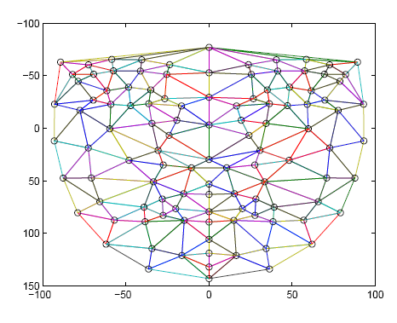
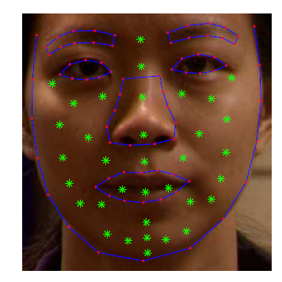

2D Facial Images
75 Feature Points Extraction using
Improved ASM
Increasing number of Feature Points Using a Template
Building the
Attributed Relational Graph
Similarity Measure
Database
Recognized face

